Farm Africa’s Mahale Mountains Challenge social media content
Please see below content for your employer to use on their social media channels to showcase your Mahale Mountains Challenge and your support for Farm Africa.
Please feel free to amend the copy as you wish, just remember to tag Farm Africa and include the photo credits in the third ‘Farm Africa post’ and fourth ‘Project post’. The link included in these posts goes to the team’s Just Giving page so please change to your personal Just Giving page.
Images are provided for each post in the accompanying email in three different formats: landscape for Facebook, Twitter and LinkedIn, square for Instagram and portrait for Instagram stories.

- General post
Images:
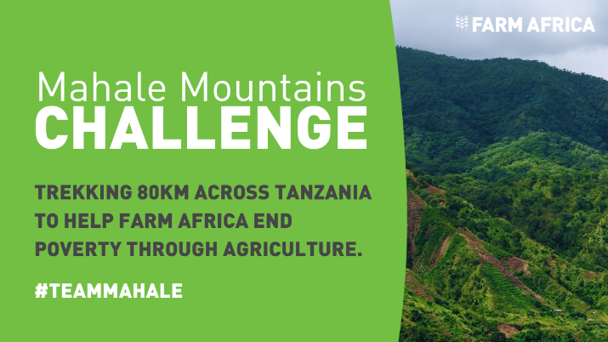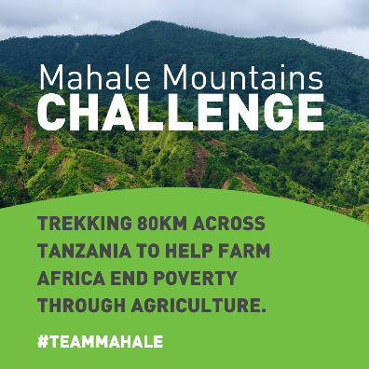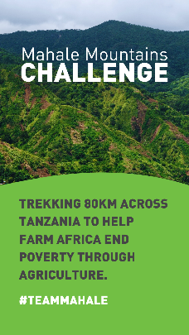
Landscape for Facebook, Twitter and LinkedIn. Square for Instagram. Portrait for Instagram story.
Copy:
We are excited to share that our very own [insert participant’s name] is taking on the Mahale Mountains Challenge in Tanzania in support of @FarmAfrica!
Over six days this September, [insert participant’s name] will be trekking across 80km of rough terrain in sweltering heat with #TeamMahale to help reduce poverty in eastern Africa.
Please help make a difference by donating here 👇 https://www.justgiving.com/campaign/mahale-mountains-challenge
#Tanzania #Fundraise #MahaleMountains
Twitter copy:
This September [insert company’s name]’s [insert participant’s name] is taking on the Mahale Mountains Challenge in Tanzania in support of @FarmAfrica!
[Insert participant’s name] will trek 80km with #TeamMahale to help reduce poverty in eastern Africa.
Please help make a difference by sponsoring [insert participant’s name]:
https://www.justgiving.com/campaign/mahale-mountains-challenge
- Training post
Images:
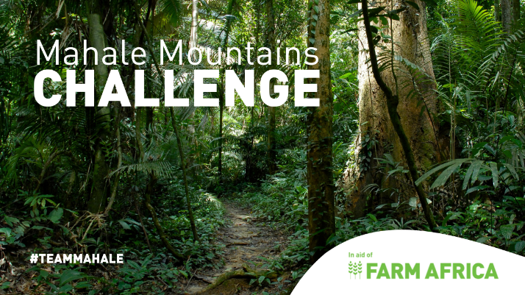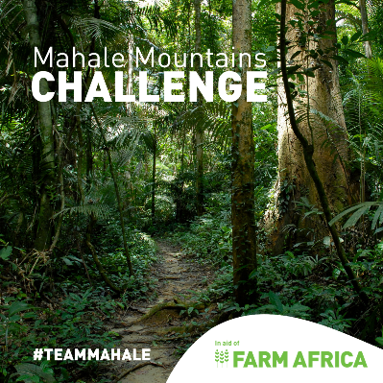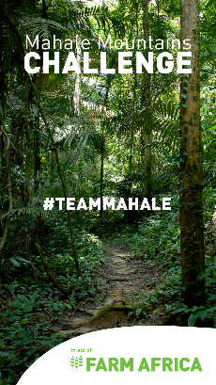
Landscape for Facebook, Twitter and LinkedIn. Square for Instagram. Portrait for Instagram story.
Copy:
In just a few weeks [insert participant’s name] is off to western Tanzania to take on the Mahale Mountains Challenge with #TeamMahale for @FarmAfrica.
It will be a physical challenge of resilience, heat, dust and distance.
[Insert participant’s name] has been training with walks covering xx km a day/week. [Personalise with training experiences.]
Any donation, big or small, would be hugely appreciated. Thank you! 🙏
https://www.justgiving.com/campaign/mahale-mountains-challenge
#Tanzania #Fundraise #MahaleMountains
Twitter copy:
In a few weeks [insert participant’s name] is taking on the Mahale Mountains Challenge with #TeamMahale for @FarmAfrica.
[Insert participant’s name] has been training with walks covering xx km a day/week.
Any donation, big or small, would be fantastic. Thank you!
https://www.justgiving.com/campaign/mahale-mountains-challenge

- Farm Africa post
Images:
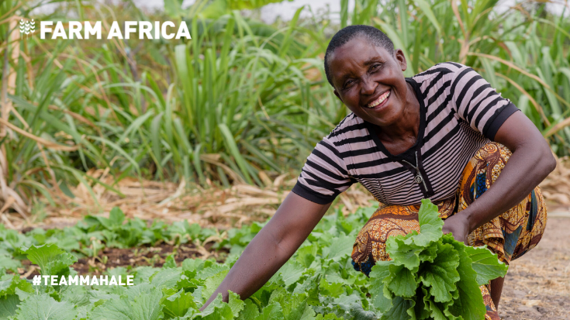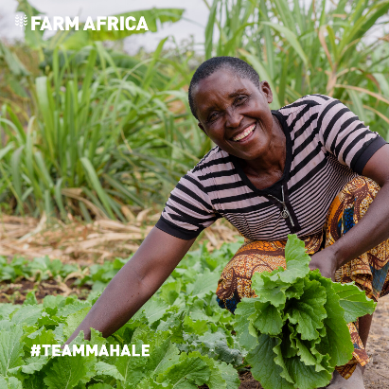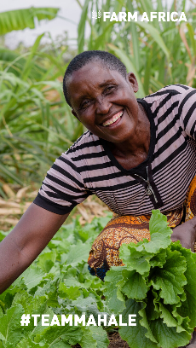
Landscape for Facebook, Twitter and LinkedIn. Square for Instagram. Portrait for Instagram story.
Copy:
Thanks so much to everyone who has already donated to [insert participant’s name]’s Mahale Mountains Challenge for @FarmAfrica. Your support is hugely appreciated.
Farm Africa is a charity that reduces poverty in eastern Africa by supporting smallholder farmers to grow more, sell more and sell for more.
Today, more than half of the world’s extreme poor live in sub-Saharan Africa, and the vast majority work in agriculture.
You can learn more about Farm Africa’s work, [insert participant’s name]’s challenge and make a donation here: https://www.justgiving.com/campaign/mahale-mountains-challenge
Photo: Michael Goima
#TeamMahale #Tanzania #Fundraise #MahaleMountains
Twitter copy:
Huge thanks to everyone who has already donated to [insert participant’s name]’s Mahale Mountains Challenge for @FarmAfrica. Your donation will help transform lives.
Farm Africa is a charity that reduces poverty in eastern Africa. If you haven't donated, it's not too late!
https://www.justgiving.com/campaign/mahale-mountains-challenge

4. Project post
Images:
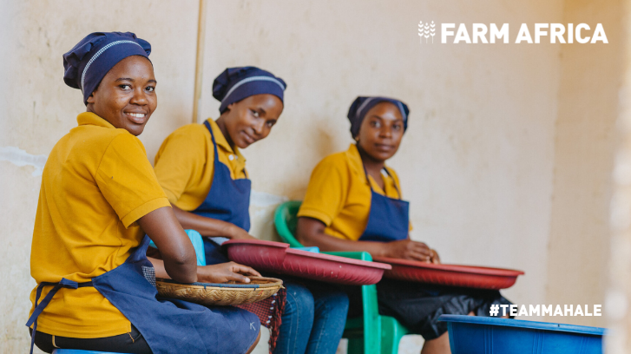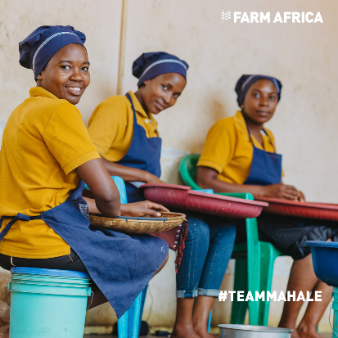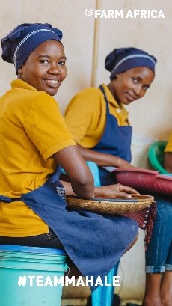
Landscape for Facebook, Twitter and LinkedIn. Square for Instagram. Portrait for Instagram story.
Copy:
It’s not long until [insert company’s name]’s [insert participant’s name] flies to Tanzania with #TeamMahale for @FarmAfrica! After eight days of trekking, the team will have the chance to meet some of the people Farm Africa has worked with.
Tanzania has a booming horticultural sector and Farm Africa supports a range of small and medium-sized enterprises to tap into the sector’s prosperity and evolve into profitable agribusinesses.
You can find out more about Farm Africa and sponsor [insert participant’s name]’s Mahale Mountains Challenge here:
https://www.justgiving.com/campaign/mahale-mountains-challenge
Photo: Kababah Digital Media
#Tanzania #Agribusiness #Fundraise #MahaleMountains
Twitter copy:
It’s not long until [insert company’s name]’s [insert participant’s name] flies to Tanzania with #TeamMahale for @FarmAfrica!
After six days of trekking, the team will have the chance to meet some of the people Farm Africa has worked with. Find out more:
https://www.justgiving.com/campaign/mahale-mountains-challenge

- Countdown post
Images:
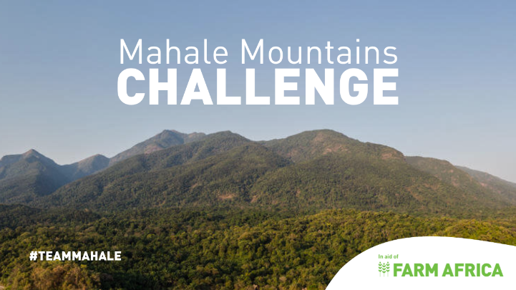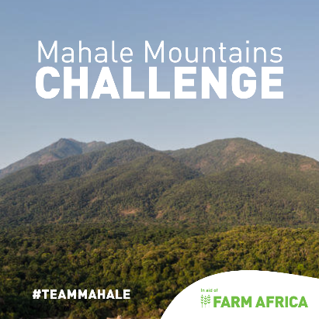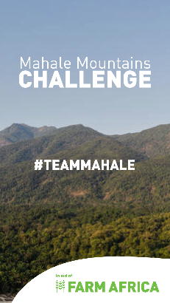
Landscape for Facebook, Twitter and LinkedIn. Square for Instagram. Portrait for Instagram story.
Copy:
The countdown is on! Only x weeks to go until [insert participant’s name]’s Mahale Mountains challenge for @FarmAfrica. ⌛️
It’ll be a tough week-long trek but it’s all for a good cause – reducing poverty in eastern Africa.
If you can spare a donation, please sponsor [insert participant’s name] here: https://www.justgiving.com/campaign/mahale-mountains-challenge
#TeamMahale #Tanzania #Fundraise #MahaleMountains
Twitter copy:
Only x weeks to go until [insert participant’s name]’s Mahale Mountains challenge for @FarmAfrica. ⌛️
It’ll be a tough week-long trek but it’s all for a good cause – reducing poverty in eastern Africa.
If you can spare a donation, please sponsor [insert participant’s name]: https://www.justgiving.com/campaign/mahale-mountains-challenge

Tags
Facebook, Twitter and LinkedIn: @FarmAfrica
Instagram: Farm_Africa

Hashtags
#TeamMahale
#FarmAfrica
#Tanzania
#MondayMotivation
#TuesdayThoughts
#ThursdayThoughts
#FridayFeeling
#Fundraise
#Farming
#Agriculture

