Suggested newsletter text
Join us to help African farmers give hunger the boot!
This Harvest we are fundraising for Farm Africa and helping farmers like David.
David is a Pastor and lives with his family in Kitui, Kenya where drought is common. Before working with Farm Africa, the fragile crops of maize he planted did not survive when the rains failed.
Whenever David did manage to reap a small harvest to sell, he was desperate for money. Forced to sell to passing traders or at the local market, he often got a lower price than his produce was worth. David struggled to provide for his family and to send his children to school.
This Harvest, the money we raise could help farmers like David to begin planting high-quality seeds for drought-tolerant crops such as sorghum and green grams (mung beans). We could help teach farmers how to make the best use of every drop of rain that falls, as well as bring farmers together as a group to sell their produce in bulk so they can demand a higher price.
To raise money for Farm Africa, we will be (add details of your fundraising, events or Harvest service here) on (insert date/s here) and we want you to get involved.
(Include details of how to get involved if necessary such as “bring a donation to our special Harvest service.”)
You can read more about Farm Africa’s work and how you can help this Harvest by visiting www.farmafrica.org/harvest
We hope you will support our fundraising. The money we raise will truly help to change the lives of farmers and their families in eastern Africa.
Thank you.
Farm Africa information
Farm Africa is a registered charity no. 326901
Website: www.farmafrica.org
Contact: Fundraising team
Telephone: 020 7430 0440
Email: community@farmafrica.org

Farm Africa logo:
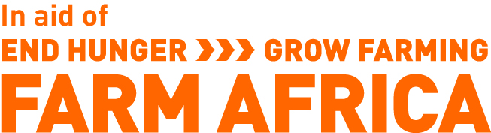
Give Hunger the Boot logo:
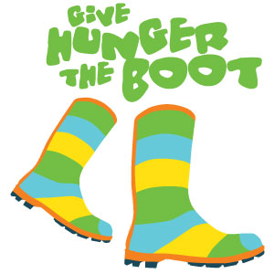

Please do not edit these logos by changing the shape or colours or amend by cropping them. If you need to resize these logos, please drag the image from the corners to ensure you keep the correct proportions. Thank you.

